Updates for custom Modules
- In this screen there is currenty only one layout per account – keep it like this !!! and then – Telete the buttons “Select layout” and “New layout” Instead update the heading – “drag and drop Widgets in your Canvas “

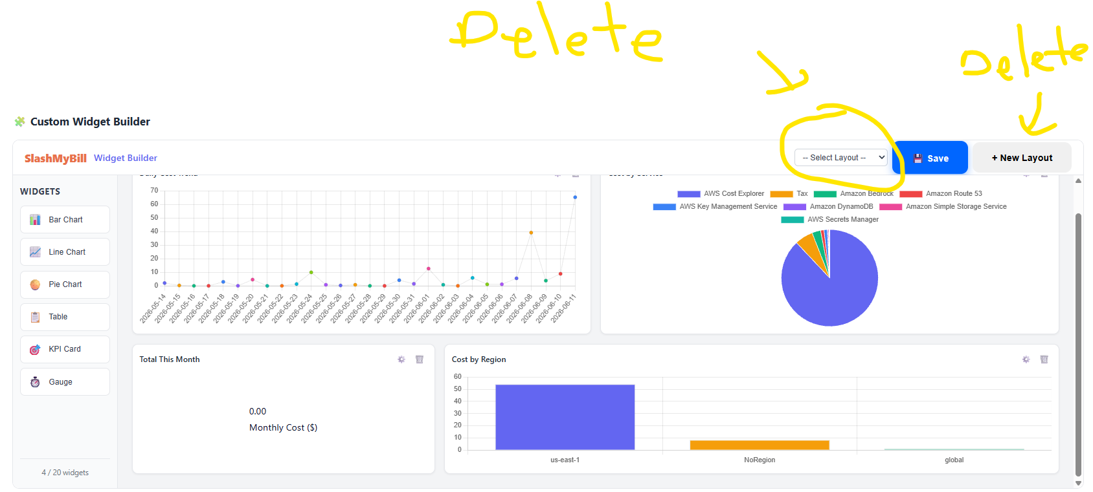

- When Selecting the Data “Settings” here are the main features:
Data Source : The Data Source represents a table in the system ( DynamoDB) :
Data Source | X-Axis | Filter /Grouping | Aggregation
Cost (Cloud) | Service ID  Service Name | Account  Provider  Tag  Service | Cost  Count (Number of)
Cost (AI) | Project  Model | Tag  Project  Model | Cost  Count(Number of )
- Timeframe: keep the timefrae as it is now
- Behaviors’ :
Always present the X and Y data Labels
When hovering mouse over data – present the value of the data itself

- Charts :

Chart Type | Modifications
Bar Chart | Add the ability to accumulate of to present the breakdown per time (for instance the services breaking by day/month)  Add the ability to present only the Diff from previous period instead of the absolute values
Line Chart | Add the ability to accumulate of to present the breakdown per time (for instance the services breaking by day/month)  Add the ability to present only the Diff from previous period instead of the absolute values
Pie Chart | Add the values for each one (%, absolute )
Table | Remove
KPI Card | Remove
Gauge | Remove

